
ENA Research Group

Country Risk and Foreign Exchange
Maureen Raymond-Castañeda
Gwyn E. Koepke

GLOBAL MARKETS MONITOR

12 January 2001

Economic and Central Bank Monitor
North America
- The Link Between Bush’s Proposed Tax Cut and the Fed’s Interest Rate Policy: Discussion of possible remedies to prevent a U.S. recession raises an interesting question regarding the link between U.S. fiscal policy and monetary policy. Following the Fed’s preemptive move last week to cut interest rates by a half-point, the heated political debate surrounding the President-elect’s aggressive $1.3 trillion 10-year tax cut plan has led to a debate about the economic rationale of coupling Fed easing with fiscal easing to stimulate the U.S. economy. At issue is the expected time lag between implementation of a policy change and its measurable impact on economic activity and the expected impact of a policy choice on long-term interest rates. Many economists advocate interest rate cuts complemented by a reduction in income taxes to support the economy. To safeguard growth in the world economy, IMF chief Horst Kohler wrote this week, there is room for both expansionary fiscal and monetary policy in the U.S. to avert recession. Others, including Alan Greenspan, strongly favor national debt reduction and probably fear that tax cuts financed by heavy government borrowing would deteriorate the fiscal budget and lead to higher long-term interest rates (as borrowing costs over time are pushed up by government crowding out). However, the U.S. enjoys a fiscal surplus. The question becomes how large the tax cuts would be, what proportion of the program is made up of income tax cuts, the implementation timeframe, and whether the fiscal surplus can keep pace with reductions in tax revenue due to the slowing U.S. economy without causing a rise in long-term borrowing costs. While tax cuts may lead to greater Keynesian economic expansion, the effect of higher interest rates could lead to an economic contraction.
- Do the World’s Major Central Banks Expect a U.S. Recession This Year? Although a handful of Wall Street economists predict that the U.S. would fall into recession by June of this year, all G10 central bankers meeting in Basle this week believe, by contrast, that the fundamental strength of the U.S. economy will lead to 2-3 percent growth this year. One objective of central banks is to instill confidence. Two Fed presidents, who said in public statements this week that growth of 2-3 percent in the U.S. is likely, share this view. Cathy Minehan, president of the Boston Fed, said she continues to expect a soft landing for the U.S. economy while acknowledging a growing measure of downside risks. But “the health of the housing market is one indicator that consumers remain reasonably confident about the future”, she stated. However, consumer confidence as measured by the Conference Board’s index shows a precipitous decline in November as the wealth effect of falling stocks prices has depressed consumer willingness to spend (refer to Chart 1). In fact, Goldman Sachs estimates that household net worth fell about $875 billion in the fourth quarter, depressing the ratio of net worth to disposable income 0.4 points below its March 2000 level, an unprecedented decline. This drop indicates a substantial contraction in consumer spending due to the drop in wealth as households attempt to increase their saving.
- U.S. Producer Prices Tame But 4th Quarter Retail Sales Worst in 10 Years: Producer prices showed no change in December despite the spike in natural gas and power prices in many parts of the country. This follows a 0.1 percent rise in November and a 0.4 percent advance in October. The energy component of the index actually fell in December by 0.7 percent, after rising 0.4 in November and 1.4 in October. The core PPI index, which excludes food and energy, rose 0.3 percent and was concentrated in motor vehicles. From December 1999 to December 2000, finished goods prices advanced 3.6 percent after rising 2.9 percent during 1999. However, higher natural gas and power prices should be evident in the January release. Retail sales in the U.S. rose 0.1 percent in December after declining 0.5 percent in November. Consensus forecasts expected sales in December to drop by 0.5 percent. Fourth quarter retail sales fell at a 2.0 percent annualized rate, the worst performance in 10 years. We hold to our expectation that the Fed will trim rates by 25 basis points at the end of the month.
- California Energy Crisis and Utility Cash Crunch – What to do? Despite several meetings and policy proposals, no far-reaching solution has been reached. Hosted by U.S. Treasury Secretary Larry Summers, a meeting between senior U.S. officials, power suppliers (including Enron) and California’s governor was held this week to craft an action plan to combat the energy crunch in the world’s sixth largest economy. Also at issue is the risk of insolvency stemming from the $11.5 billion owed to power generators by PG&E and Edison International, who are on the brink of bankruptcy. Since many observers found Governor Davis’ recent “State of the State” address short of concrete steps to address the power shortage and surging prices, the question is whether the state, U.S. regulators, creditors and power suppliers can fashion a viable solution to the financial and energy crisis and how quickly it could be implemented to avert a state-wide recession. Power generators may help with short-term debt relief by extending terms in an agreement expected this week, which would help ease credit concerns further aggravated this week by Governor Davis’ statement that the state wouldn’t provide the utility owners with short-term loan guarantees. A debt repayment compromise with suppliers may also prevent large rate increases to consumers beyond the 10 percent increase already approved by the state. To avoid power blackouts, one plan calls for the California Department of Water Resources or a proposed state power authority to act as agent to buy power for the utilities and collect payment under flexible terms. The urgency to conserve power in California has been heightened by high seas that threaten to disrupt power output generated from the Diablo Canyon nuclear plant. Also under discussion is the promotion of long-term contracts between the utilities and power generators to reduce the utility’s exposure to spot market price spikes.
- “Good Bank/Bad Bank” Deal Helps Bank Sell-Off Bad Loans: To help strengthen the bank’s balance sheet, FleetBoston sold $1.35 billion in troubled loans (about 10 percent are non-performing loans) to a fund management firm who will focus on recovering the maximum value from those loans. This “good bank/bad bank” model was deployed in the early 1990s by U.S. regulators to address the S&L banking crises, yet FleetBoston is considered a healthy and viable financial institution. Concerns about deteriorating credit quality of U.S. bank loans have increased recently, most notably at Bank of America, who reports that loan write-offs in 4Q00 would hit $1.2 billion, more than double the level of an already worrisome third quarter.
- 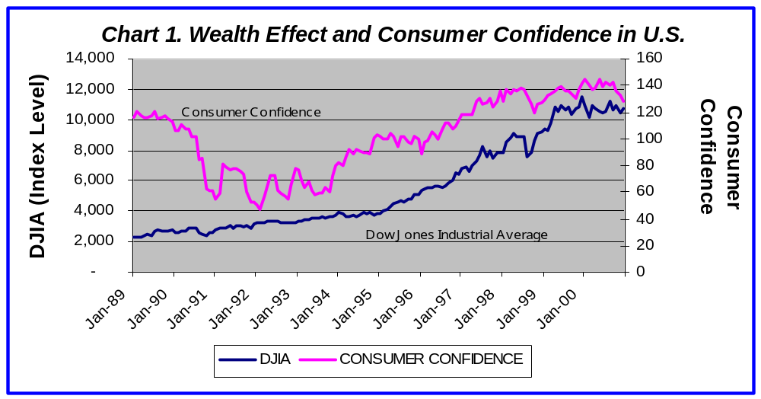Canadian Growth Prospects: Canada’s Finance Minister Paul Martin believes that Canada’s shift from a primarily natural resources-based economy to a service and high-technology directed economy should limit the impact of any U.S. slowdown on Canadian economic growth. He expects GDP to grow over 3 percent in 2001 following growth of about 5 percent last year and predicts a soft landing in the U.S. By contrast, one of Canada’s largest banks, cut its 2001 growth forecast from 3 percent to 1.6 percent for 2001, fearing a deterioration in Canadian exports to the U.S. and the impact of the U.S. economic slowdown on the Canadian motor industry. The slump in U.S. and Canadian car sales is leading to production cuts in Canada. Since the U.S. buys the majority of Canadian exports and Canada’s trade balance with the U.S. has risen about 270 percent since early 1998, it is clear that the U.S. economic slowdown is going to have a substantial impact on Canada’s economy.

Europe
- BOE Holds But Some Hoped For Rate Cuts: As expected, the Bank of England held rates steady this week despite calls from Britain’s Confederation of British Industry (CBI) and the British Chamber of Commerce to shave a quarter-point off the current 6.0 percent level. Rates in the U.K have been kept constant at 6.0 percent for 11 consecutive months, the longest period of unchanged rates for 10 years. Fears of a U.S. recession and the surprise Fed cut last week no doubt led to arguments that the BOE should act in kind to stave off a fall in consumer confidence during this period of economic uncertainty. The British Chamber of Commerce argued that inflationary pressures had been kept at bay due to fierce international price competition in the product markets and thus that there is room to lower borrowing costs. Britain has been successful in controlling inflation, which suggests the MPC can respond quickly to negative demand shocks from the U.S. It is likely that the MPC will wait to assess the effectiveness of the Fed’s rate cut before making an accommodative move. Minutes of the MPC meeting are expected January 24th. The BOE expects GDP growth of about 2.5 percent in 2001 and 2002, down from an annual rate of 3 percent in 3Q00. According to a research organization in London, a 1 percentage point decline in U.S. GDP growth will reduce expansion of Britain’s GDP by as much as 0.4 percent.
- Economic Convergence As a Test For Joining the Euro: By several economic measures, the U.K. is converging with the euro-zone economy, which may meet one test for Britain to adopt the euro. Short- and long-term interest rates, unemployment and economic output all showed signs of convergence, according to a British consultant. Britain’s economic cycle, historically more aligned with the U.S., is now more in synch with Europe’s cycle. Many euro-skeptics are still concerned about the loss of control over interest rates that euro adoption would entail, and the government warns that economic convergence does not indicate political eagerness to join the euro.
- Further Signs of a Slowdown in Europe But Outlook Positive: Production in the German manufacturing sector edged down in November by 0.20 percent month-on-month after falling 0.70 percent during each of the previous two months (three consecutive months of dips hasn’t occurred since the mid-1990s). November’s slip is attributable to a slowdown in the consumer and durable goods sectors. Overall industrial production in Germany, however, which includes mining, electricity and gas supply and construction, crept up 0.4 percent in November over October after two consecutive months of contraction. Germany is still expected to grow 2.8 percent in 2001, the unemployment rate is falling (but still twice as high as the U.S. rate) and the income and corporate tax cut is expected to boost spending this year. Many companies in Germany are hiring and car sales are expected to rise on a stronger economy.

Asia/Pacific
- Nikkei Suffers New Lows While Yen Extends Losses Against U.S. Dollar: The Nikkei fell to a one year low of 13,201.07 Thursday on concerns about a weak banking system and sluggish economic growth dragged down by a slump in consumer spending. Falling stock prices have eroded the capital base of many Japanese banks, threatening their capital adequacy ratios. Stocks have weakened 12 percent since mid-December in part because banks have sold off unprofitable positions in anticipation of their fiscal year end on March 31. Some analysts fear a credit crisis in the near-term due to these banking problems. According to one opposition party leader, the government should sell convertible bonds and use the proceeds to shore up stock prices. Some members of the LDP have suggested that Y10,000bn be injected into the banks’ capital bases. Steep declines in stocks have hurt the yen, which hit Y118.49 Friday. Expect that more demands will arise for government action to stem the slide in stocks and that a yen with upward momentum will reach at least Y120 as Japanese officials have not been shy to talk down the yen.
- Miyazawa’s Stock Market Theory: Asked about his opinion on recent stock market woes, Japanese Minister of Finance stated that the “Japanese economy will gain momentum from now, while (stock) markets will move in whichever direction they like. What I am worried about is when will consumer spending pick up.”

Commodity News
- Higher Power Prices Provide Powerful Incentive to Aluminum Producer to Cut Production: Alcoa, one of the largest aluminum producers in the U.S., is going to cut smelter production in the northwestern U.S. by 150,000 tonnes per year due to the soaring cost of power. By some estimates, as many as 980,000 tonnes have been cut thus far in the northwest during the current power crisis, or 60 percent of total northwestern U.S. smelting capacity. Global primary aluminum production is 22.7 million metric tons per year. Many aluminum companies are finding that they can make more money selling their lower-cost power back to the market than producing aluminum. Interestingly, new long-term contracts expected to be signed later this year with the local government agency that sells power in the U.S. northeast apparently will not allow smelters to remarket the power. Provisions such as these would remove the incentive for producers to shutdown operations in the near-term due to higher power prices.

G-7+ Central Bank Monitor
Country | Official Interest Rate | Current (%) | Change from prev. bias | Last Change | Next MPC Mtg.
The Americas
United States | Federal funds rate | 6.00 | 19 Dec 00 (-50 bps) | 3 Jan 01 (-50bps) | 30-31 Jan 2001
Canada | Overnight rate | 5.75 | 3 May 99 (+125 bps) | 17 May 00 (+50bps) | 23 Jan 2001
Europe
ECB | ECB rate | 4.75 | 4 Nov 99 (+225 bps) | 5 Oct 00 (+25 bps) | 18 Jan 2001
U.K. | Base rate | 6.00 | 8 May 99 (+100 bps) | 10 Feb 00 (+25 bps) | 10/11 Jan 2001
Asia/Pacific
Australia | RBA Cash rate | 6.25 | 2 Nov 99 (+150 bps) | 2 Aug 00 (25 bps) | 6 Feb 2001
New Zealand | Cash rate | 6.50 | 16 Nov 99 (+200 bps) | 17 May 00 (+50 bps) | 14 Mar 2001
Japan | Overnight call rate | 0.25 | 17 Aug 00 (+24 bps) | 17 Aug 00 (+25 bps) | 19 Jan 2001

Economic Calendar – January 15 to January 19, 2000 (all times are CST)
Country | Mon. Jan.15 |  | Tues. Jan.16 | Wed. Jan17 |  | Thurs. Jan.18 | Fri. Jan.19
The Americas
U.S. | Federal Holiday  Martin Luther King Jr. Day  Financial Markets Closed | Business Inventories (Nov)  Redbook  Auction of T-Bills: $23.0 Bil |  | Mortgage Applications (Jan 12)  CPI (Dec)  Real Earnings (Dec)  Industrial Production (Dec)  Homebuilders Survey (Jan)  Capacity Utilization (Dec)  Fed Beige Book  Announcement of 2-year notes: $10.0Bil  OPEC Meeting  Fed President Santomero speaks  in Berwyn, PA |  | Jobless Claims  (Jan 13)  Housing Starts (Dec)  Philadelphia Fed Survey (Jan)  Auction of Buybacks: $1.0 Bil  Fed President Poole to address the Risk Management association in Memphis, TN | Trade Balance (Nov)  U of Mich Confid. (Jan Prelim)
Canada | Domestic Motor Vehicle Sales (Nov) |  |  |  |  | CPI (Dec)  Wholesale Sales (Nov) | Trade Balance (Nov)  Merchandise Exports (Nov)  Merchandise Imports (Nov)
Europe
ECB | Germany: Retail Sales (Nov) | Euroland: GDP (Q300)  Germany: Retail Sales (Nov)  Wholesale Prices (Dec)  France: Trade Balance (Nov) |  | Euroland: Industrial Production (Nov)  Italy: Industrial Production (Nov) | Italy: Final CPI (Dec)  ECB Meeting |  | France: IP (Nov)  Manufacturing Production (Nov)  Italy: Industrial Orders (Oct)
U.K. | Producer Prices (Dec) | Retail Prices (Dec)  Harmonised CPI (Dec) |  | Labor Market ( Nov/Dec) Unemployment Rate (Dec)  Vacancies (Dec)  Average Earnings | Retail Sales (Dec)  BCC Survey (Q4) |  | Money Supply (Dec)  Public Finances (Dec)
Japan | Current Account Balance (Nov) | Machinery Orders (Nov)  Crude Steel Production (Nov) |  | 20-year JGB Auction  Industrial Production (Nov) | Manufacturing Operating Rate (Nov)  BOJ Policy-Setting Board Meeting |  | Bankruptcies (Dec)
Australia |  | Housing Finance (Nov) |  |  | Export Price Index (Q4) |  | Producer Output Prices (Q4)
NZ |  | Food Price Index (Dec) |  | CPI (Q4) | Overseas Trade Export (Nov) |  | Trade Balance (Nov)  Retail Sales (Nov)
Singapore |  | Retail Sales (Nov) |  | Trade Balance (Dec)

